**1st Feb 2021**

**19B32(20048-5)----in the issue list**

FAT inspection General Points：

Threading for instrument nozzles to be sound and same size as drawing------need change

Manhole Davit to be vertical after installation ----------------NA

Location of lifting and tailing lug to be checked vs drawing-------acceptable

Existing of 2 earthing lugs to be verified---------acceptable

Nozzle pads to be verified vs drawing (dimension)------have not nozzle pads

Anchoring to be verified with drawing ------acceptable

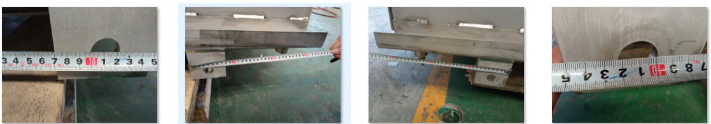

For vessels on bracket, internal diameter of the vessel to be verified for ovality at the location of brackets------NA

For all coils inside, make sure that the nuts are tag welded to U-bolts------NA

PMI control of the liner for manhole covers-100% check----NA

Control of Liner welding for manhole covers---- -NA

All top lids for flat tanks to be with bolt----need check top lids be with blot

Sight glasses to be installed before shipping ---- -NA

Comissioning spare parts to be checked----- did not to do

Flatness of sight glasse flange to be checked for each sight glass, before mounting the glass---- -NA

Bolts and gaskets for loose parts to be also included in delivery (bolts and nuts to be mounted and tight enough)------ did not to do

For nozzles with internal elbows shown on drawing, check the elbow exists inside the tank--------checked not elbow exist inside.

Check shell-top and bottom head thickness with UT ------LH checked thickness, the data marked on the tank face. the details refer to LH data sheet.

Check zero measurements are marked on the vessels-------acceptable

**Special points:** Check level regulator operation by moving handle up and down (shall be smooth operatin but not loose)---acceptable

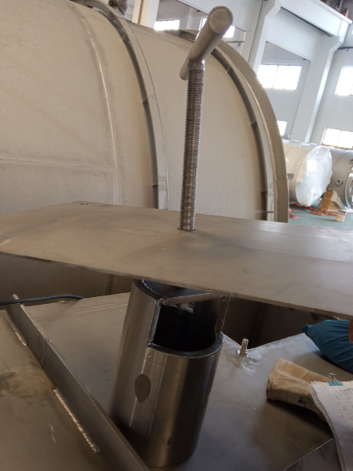

check o-ring in drawing 9684068099 is in place, for oil regulator box detail view on the main drawing 9684064607

check dimensions 350 and 600,------acceptable

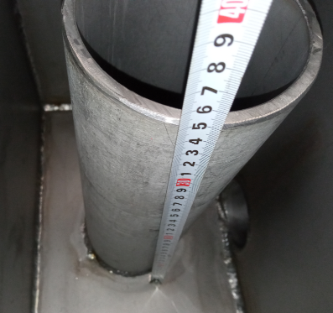 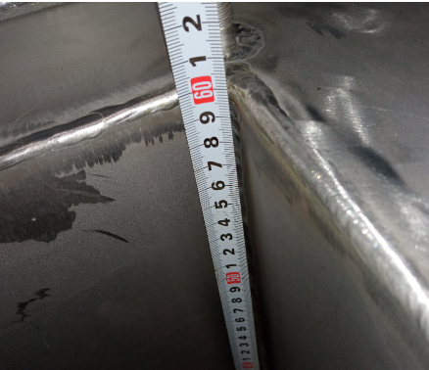

for dividing plate position 5 on drawing 9684064607 check dimension 1504 shown on right hand side view----acceptable , on the right view

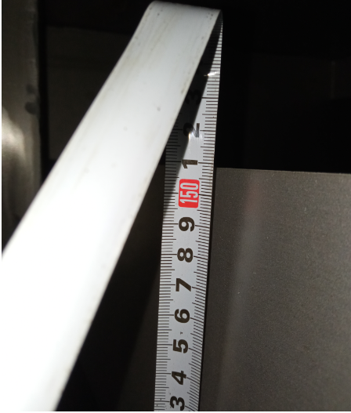

check assembly of sparge pipe and Up sign as shown on view F-F on main drawing 9684064607-----acceptable, the dimension is acceptable

